11.61: a) Taking torques about the hinged end of the pole
. Therefore the y-component of
the tension is 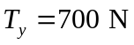. The x-component of the tension is then 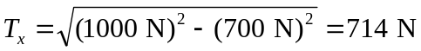. The height above the pole that the wire must be attached is 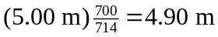. b) The y-component of the tension remains 700 N and the x-component becomes 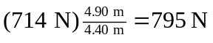, leading to a total tension of 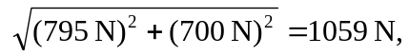 an increase of 59 N.

